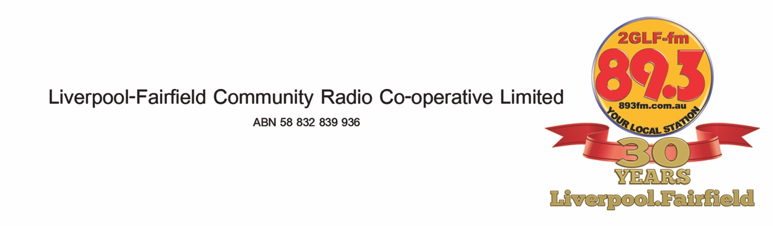

2GLF Training 2016
Commencing Monday 1st February 2016
Week 1 - Monday 1st February 2014
7.00pm to 9.00pm
- Introduction to the course, radio sectors and where 2GLF fits into the overall broadcasting industry
Week 2 – Monday 8th February 2016
7.00pm to 9.00pm
- Presenting on air
Week 3 – Monday 15th February 2016
7.00pm to 9.00pm
- Writing for radio
Week 4 – Monday 29th February 2016
7.00pm to 9.00pm
- Planning a Program
Week 5 – Monday 7th March 2016
7.00pm to 9.00pm
- Interviewing
Week 6 – 14th March 2016
7.00pm to 9.00pm
- Media Law
Week 7 – 22th March 2014
7.00pm to 9.00pm
- Media Law and course round up

Editing (the eighth topic) will be a session held at the studio and taken in small groups.
In addition you will be required to attend eight evening sessions (duration of 2hours each) for panel training held at the studios.. During the Monday session on 1st February 2016 the groups for panel training will be formed on the basis of the evening the trainee prefers. The content for those sessions will be:
Session 1
An Introduction to the panel
Session 2
Panel Operation (You will need your headphones and some CDs)
Session 3
Microphone Technique
Session 4
Recording a program segment
Session 5
Introduction to Simian
Session 6
Simian continued
Session 7
Recording a 20 minute segment for air play
Session 8
Review
Carol North-Samardzic
carol@893fm.com.au

